

| **TITLE:** Implementation of Basic Process management algorithms – Non Pre-emptive ( FCFS , SJF, priority) |
| --- |

**_____________________________________________________________________**

**AIM:** To implement basic Non –Pre-emptive Process management algorithms ( FCFS , SJF , Priority)

**______________________________________________________________________**

**Expected Outcome of Experiment:**

**CO 2.** To understand the concept of process, thread and resource management.

**_____________________________________________________________________**

**Books/ Journals/ Websites referred:**

1. **Silberschatz A., Galvin P., Gagne G. “Operating Systems Principles”, Willey Eight edition.**
2. **Achyut S. Godbole , Atul Kahate “Operating Systems” McGraw Hill Third**

**Edition.**

1. **William Stallings, “Operating System Internal & Design Principles”, Pearson.**
2. **Andrew S. Tanenbaum, “Modern Operating System”, Prentice Hall.**

**_____________________________________________________________________**

**Pre Lab/ Prior Concepts:**

Most systems have a large number of processes with short CPU bursts interspersed between I/O requests and a small number of processes with long CPU bursts. To provide good time-sharing performance, we may preempt a running process to let another one run. The ready list, also known as a run queue, in the operating system keeps a list of all processes that are ready to run and not blocked on some I/O or other system request, such as a semaphore. Then entries in this list are pointers to the process control block, which stores all information and state about a process.

When an I/O request for a process is complete, the process moves from the *waiting* state to the *ready* state and gets placed on the run queue.

The process scheduler is the component of the operating system that is responsible for deciding whether the currently running process should continue running and, if not, which process should run next. There are four events that may occur where the scheduler needs to step in and make this decision:

1. The current process goes from the *running* to the *waiting* state because it issues an I/O request or some operating system request that cannot be satisfied immediately.
2. The current process terminates.
3. A timer interrupt causes the scheduler to run and decide that a process has run for its allotted interval of time and it is time to move it from the *running* to the *ready* state.
4. An I/O operation is complete for a process that requested it and the process now moves from the *waiting* to the*ready* state. The scheduler may then decide to preempt the currently-running process and move this *ready* process into the *running* state.

The decisions that the scheduler makes concerning the sequence and length of time that processes may run is called the scheduling algorithm (or scheduling policy). These decisions are not easy ones, as the scheduler has only a limited amount of information about the processes that are ready to run. A good scheduling algorithm should:

1. Be fair – give each process a fair share of the CPU, allow each process to run in a reasonable amount of time.
2. Be efficient – keep the CPU busy all the time.
3. Maximize throughput – service the largest possible number of jobs in a given amount of time; minimize the amount of time users must wait for their results.
4. Minimize response time – interactive users should see good performance
5. Minimize overhead – don’t waste too many resources. Keep scheduling time and context switch time at a minimum.
6. Maximize resource use – favor processes that will use underutilized resources. There are two motives for this. Most devices are slow compared to CPU operations. We’ll achieve better system throughput by keeping devices busy as often as possible. The second reason is that a process may be holding a key resource and other, possibly more important, processes cannot use it until it is released. Giving the process more CPU time may free up the resource quicker.
7. Avoid indefinite postponement – every process should get a chance to run eventually.

_____________________________________________________________________

**Description of the application to be implemented**:

**First-Come, First-Served Scheduling:**

First Come First Serve (FCFS) is an operating system scheduling algorithm that

automatically executes queued requests and processes in order of their arrival. It is the

easiest and simplest CPU scheduling algorithm. In this type of algorithm, processes

which requests the CPU first get the CPU allocation first. This is managed with a FIFO

queue. The full form of FCFS is First Come First Serve.

As the process enters the ready queue, its PCB (Process Control Block) is linked with

the tail of the queue and, when the CPU becomes free, it should be assigned to the

process at the beginning of the queue.

# Shortest job first :

Shortest Job First (SJF) is an algorithm in which the process having the smallest

execution time is chosen for the next execution. This scheduling method can be

preemptive or non-preemptive. It significantly reduces the average waiting time for

other processes awaiting execution. The full form of SJF is Shortest Job First.

There are basically two types of SJF methods: Non-Preemptive SJF and Preemptive SJF.

# Priority scheduling

Priority Scheduling is a method of scheduling processes that is based on priority. In this algorithm, the scheduler selects the tasks to work as per the priority. The processes with higher priority should be carried out first, whereas jobs with equal priorities are carried out on a round-robin or FCFS basis. Priority depends upon memory requirements, time requirements, etc.

**Implementation details:** (printout of code)

STRN:

def shortest_remaining_time_next():

# Take user input for processes

n = int(input("Enter number of processes: "))

processes = []

for i in range(n):

arrival_time = int(input(f"Enter Arrival Time for Process P{i+1}: "))

burst_time = int(input(f"Enter Burst Time for Process P{i+1}: "))

processes.append([f'P{i+1}', arrival_time, burst_time])

processes.sort(key=lambda x: x[1]) # Sort by arrival time

completed = 0

current_time = 0

waiting_time = [0] * n

turnaround_time = [0] * n

response_time = [-1] * n # Initialize response time with -1 (unresponded)

remaining_time = [process[2] for process in processes]

gantt_chart = []

while completed != n:

# Find process with shortest remaining time at the current time

shortest = None

for i in range(n):

if processes[i][1] <= current_time and remaining_time[i] > 0:

if shortest is None or remaining_time[i] < remaining_time[shortest]:

shortest = i

if shortest is None:

current_time += 1 # No process is ready, increment time

continue

# Process the shortest job

if response_time[shortest] == -1: # First time the process is getting CPU

response_time[shortest] = current_time - processes[shortest][1]

gantt_chart.append(processes[shortest][0])

remaining_time[shortest] -= 1

current_time += 1

if remaining_time[shortest] == 0: # Process is completed

completed += 1

finish_time = current_time

turnaround_time[shortest] = finish_time - processes[shortest][1]

waiting_time[shortest] = turnaround_time[shortest] - processes[shortest][2]

# Calculate average waiting time, turnaround time, and response time

avg_waiting_time = sum(waiting_time) / n

avg_turnaround_time = sum(turnaround_time) / n

avg_response_time = sum(response_time) / n

print("\nProcess\tArrival Time\tBurst Time\tWaiting Time\tTurnaround Time\tResponse Time")

for i in range(n):

print(f"{processes[i][0]}\t\t{processes[i][1]}\t\t{processes[i][2]}\t\t{waiting_time[i]}\t\t{turnaround_time[i]}\t\t{response_time[i]}")

print(f"\nAverage Waiting Time: {avg_waiting_time:.2f}")

print(f"Average Turnaround Time: {avg_turnaround_time:.2f}")

print(f"Average Response Time: {avg_response_time:.2f}")

print("\nGantt Chart:")

print(" -> ".join(gantt_chart))

# Run the SRTN Algorithm

shortest_remaining_time_next()

Output:

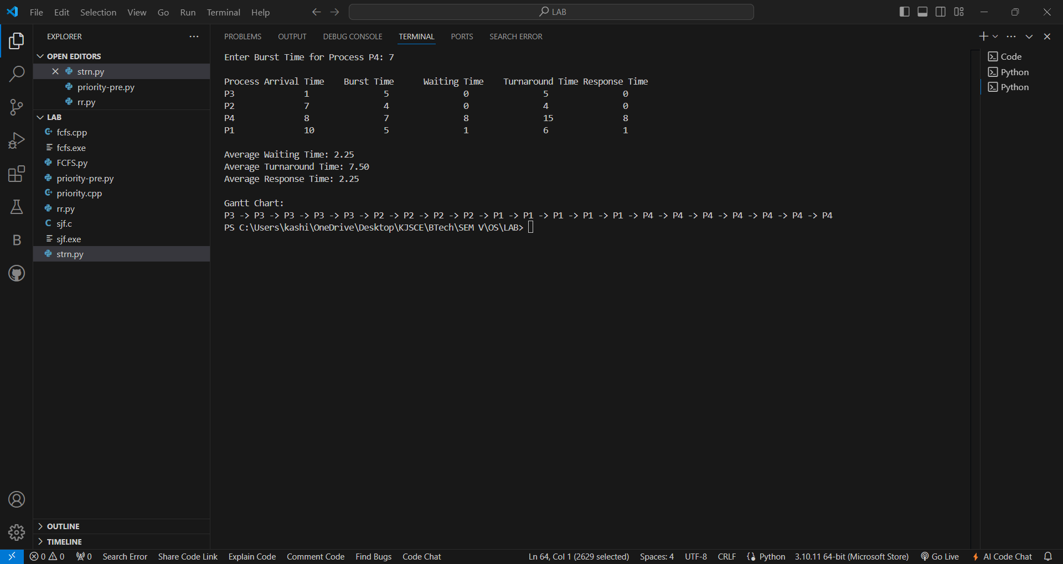

**Conclusion:**

Hence we learned about the pre-emptive scheduling algorithms and we are able to deploy it using code .

**Post Lab Objective Questions**

* 1. What is the ready state of a process?  
     a) when process is scheduled to run after some execution  
     b) when process is unable to run until some task has been completed  
     c) when process is using the CPU  
     d) none of the mentioned

**Ans: b**

* 1. A process stack does not contain  
     a) function parameters  
     b) local variables  
     c) return addresses  
     d) PID of child process

**Ans: d**

* 1. A process can be terminated due to  
     a) normal exit  
     b) fatal error  
     c) killed by another process  
     d) all of the mentioned

**Ans: d**

**Date: 16/08/2024 Signature of faculty in-charge**